Romeo and Juliet
Act I

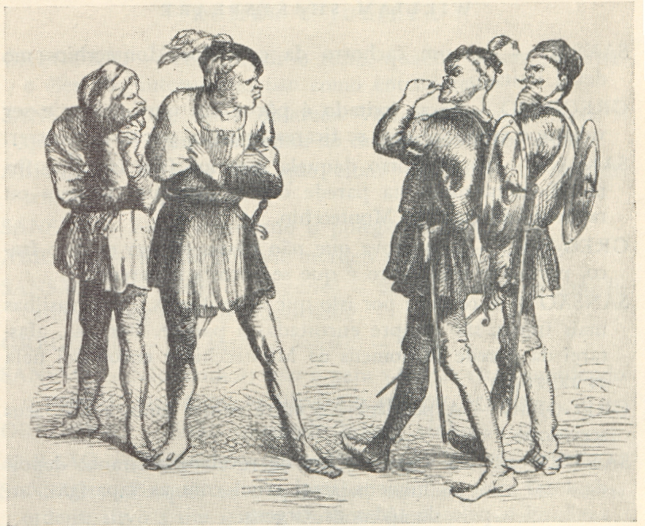

Primary Documents
Proclamations
Queen Elizabeth I

Proclamation Enforcing Statues of Apparel – May 6, 1562
And whereas an usage is crept in, contrary to former orders, of wearing of long swords and rapiers, sharpened in such sort as may appear the usage of them can not tend to defense, which ought to be the very meaning of wearing of weapons in times of peace, but to murder and evident death…her majesty’s pleasure is that no man shall, after ten days next following this proclamation, wear any sword rapier, or any weapon in their stead, passing the length of one yard and half a quarter of blade at the uttermost, neither any dagger above the length of twelve inches in blade, neither any buckler with a sharp point…upon pain of forfeiting the sword or dagger…and the imprisonment of his body that shall be found to wear any of them.

Proclamation prohibiting Unlawful Assembly under Martial Law – June 20, 1594
The Queen’s majesty, being informed of sundry great disorders committed in and about her city by unlawful great assemblies of multitudes of a popular sort of base condition, whereof some are apprentices and servants to artificers and to such like as are not able or not disposed to rule their servants as they ought to do, and some attempting to rescue out of the hands of public officers such as have been lawfully arrested; whereby her majesty’s peace hath been of late notably violated and broken to the dishonor of her majesty’s government, and chiefly for lack of due correction in time of such manifest offenders by the officers of her city and others in the places around and about her city:
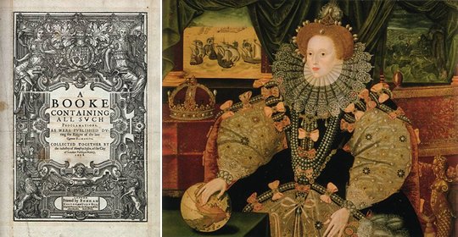
…and for that purpose meaneth to have a provost martial with sufficient authority to apprehend all such as shall not be readily reformed and corrected by the ordinary officers of justice; and them without delay to execute upon the gallows by order of martial law. And this her majesty’s commandment she willeth to be duly observed, upon pain of her indignation.

Rowlands, Samuel, 1570-1630
[from Humors Looking Glasse (1608)]

The Humors that haunt a Wife.
¹
1 A Gentleman a verie friend of mine,
2 Hath a young wife and she is monstrous fine,
3 Shee's of the new fantastique humor right,
4 In her attire an angell of the light.
5 Is she an Angell? If it may be well,
6 Not of the light, she is a light Angell.
7 Forsooth his doore must suffer alteration,
8 To entertaine her mightie huge Bom-fashion,
9 A hood's to base, a hat which she doth male,
10 With brauest feathers in the Estridge tayle.
11 She scornes to treade our former proud wiues traces.
12 That put their glory in their on faire faces,
13 In her conceit it is not faire enough,
14 She must reforme it with her painters stuffe,
15 And she is neuer merry at the heart,
16 Till she be got into her leatherne Cart.
17 Some halfe amile the Coach-man guides the raynes,
18 Then home againe, birladie she takes paines.
19 My friend seeing what humors haunt a wife,
20 If he were loose would lead a single life.

From Euphues by John Lyly (1578)
¶ EUPHVES .
THE ANATOMY OF WYT.
Very pleasant for all Gentlemen to reade, and most necessary to remember:
wherin are contained the delights that Wyt followeth in his youth by the pleasauntnesse of Loue, and the happynesse he reapeth in age, by the perfectnesse of Wisedome.
¶ By Iohn Lylly Master of Arte. Oxon.
¶ Imprinted at London for Gabriell Cawood, dwelling in Paules Churchyarde.

¶ To the right honorable my very good Lord and Master Sir William West Knight, Lord Delaware: Iohn Lyly wissheth long lyfe with encrease of honour.

To the Gentlemen Readers.
I was driuen into a quandarie Gentlemen, whether I might send this my Pamphlet to the Printer or to the pedler. I thought it to bad for the presse, & to good for the packe. But seing my folly in writing to be as great as others, I was willing my fortune should be as ill as any mans. We commonly see the booke that at Christmas lyeth bound on the Stacioners stall, at Easter to be broken in the Haberdasshers shop, which sith it is the order of proceding, I am content this winter to haue my doings read for a toye, that in sommer they may be ready for trash. It is not straunge when as the greatest wonder lasteth but nyne dayes: That a newe worke should not endure but three monethes. Gentlemen vse bookes, as gentlewomen handle theyr flowres, who in the morning sticke them in their heads, and at night strawe them at their heeles. Cheries be fulsome when they be through rype, bicause they be plety, & bookes be stale when they be printed, in that they be common. In my mynde Printers and Taylors are bound chiefely to pray for Gentlemen, the one hath so many fantasies to print, the other such diuers fashions to make, that the pressing yron of the one is neuer out of the fyre, nor the printing presse of the other any tyme lyeth still. But a fashion is but a dayes wearing, and a booke but an howres reading, which seeing it is so, I am of a shomakers mynde, who careth not so the shooe hold the plucking on, and I, so my labours last the running ouer. He that commeth in print bicause he would be knowen, is lyke the foole that commeth into the market bicause he would be seene. I am not he that seeketh prayse for his labour, but pardon for his offece, neither doe I set this foorth for any deuotion in print, but for dutie whith I owe to my Patrone. If one write neuer so well, he cannot please all, and write he neuer so ill hee shall please some. Fine heads will pick a quarrell with me if all be not curious, and flatterers a thanke, if any thing be currant. But this is my mynde, let him that fyndeth fault amende it, and him that liketh it, vse it. Enuie braggeth but draweth no bloud, the malicious haue more mynde to quippe, then might to cut. I submit my selfe to the iudgement of the wise, and I little esteme the censure of fooles. The one will be satisfyed with reason, the other are to be aunswered with silece. I know gentlemen wil fynde no fault without cause, and beare with those that deserue blame, as for others I care not for their iestes, for I neuer ment to make them my Iudges. Farewell.
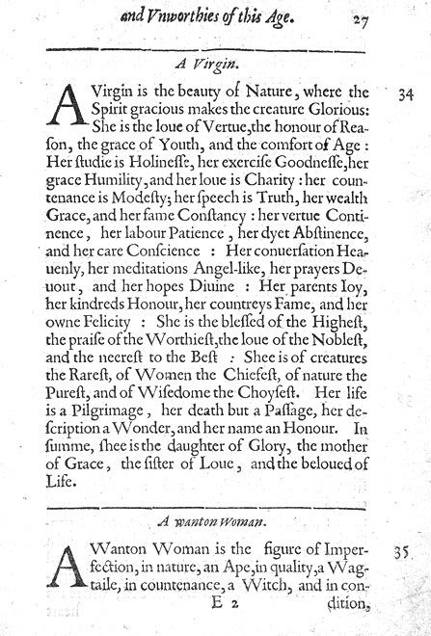

From The Praise and Dispraise of Women by C. Pyrrye (1569)

Here Beginneth the Disprayse of Women

17 This Monster is the woman kinde,
18 whose ougelye shape and port:
19 I meane to paint, writ thou my minde,
20 not forcing her report.
21 This woman kinde I know right well,
22 is comelie to the eye:
23 Of perfect shape she beares the bell,
24 I can it not denie.
25 But in her fained couert brest,
26 stronge poison she doth hide:
27 And in her harte, as in a chest,
28 a deadly stinge doth bide.
29 Which geues an helples hurtfull wounde,
30 as hath ben brought to passe:
31 Much like the snake that vnder grounde,
32 doth lie, and lurke in grasse.
33 She doth annoy by sodden sight,
34 vnlesse thou can beware:
35 And kepes the still in wofull plight,
36 once caught within her snare.
37 Her poison is so swete and pure,
38 and of suche strength and force:
39 That who so doth that same deuoure,
40 is brought vnto his corse.
41 Take hede therfore seke to discerne,
42 be this that foloweth plaine;
43 With earnest minde see thou do learne,
44 this monster to refraine.

Here Beginneth the Prayse of Women

61 I thinke thou doost not call to minde,
62 in sicknes or in health:
63 How we are holpe by woman kinde,
64 whose care is for our wealth.
65 First (as thou knowst) she takes great paine,
66 by trauelinge in bed:
67 And greuous groninges doth sustaine,
68 before she see our head.
69 As long as we poore infantes are,
70 and nought our selfes can geue:
71 So long the woman takes the care,
72 our bodies to releue.
73 When we would eate she makes the pape
74 she geues vs quiet rest:
75 She dandleth vs vpon her lappe,
76 we sucke mylke from her brest.
77 When we do naught but crie and weepe,
78 then will she sing and play:
79 Or els will lay vs downe to slepe,
80 our cryenge so to stay.
81 When we can neyther go nor stand,
82 by reason of our youth:
83 The louinge Woman takes in hande,
84 to helpe vs this is truth.

85 Now when we come to further age,
86 and can both speake and go:
87 The womans paine doth not asswage:
88 she then hath care and wo.
89 In seekinge how she may prouide,
90 to kepe vs still in health:
91 And caring how she may vs guide,
92 to liue in honest wealth.

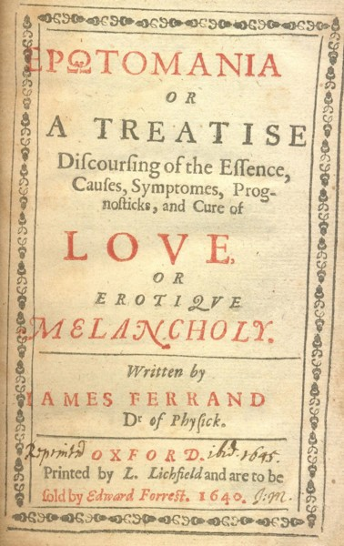
From Erotomania by Jacques Ferrand (1640)

Chapter XIV: “Signs Diagnostic of Love-Melancholy”

As this disease finds its first passage into the inward parts of the body through the eyes; so do they give the first assured and undoubted tokens of the same: For as soon as ever this malady hath seized on the patient, it causeth a certain kind of modest cast of the eye…

But if the party be over far gone with this disease, the eyes begin then to grow hollow, and dry, (unless perhaps some unkindness, or denial from their mistress, or else her absence moisten them with a tear or two and you shall observe them to stand, as if they were either in some deep contemplation, or else were earnestly fixed in beholding something or other that much delighted them.

And if the lover’s eyes be thus discomposed, and out of order; how much more think you is his heart? For you shall see him now very jocund and laughing; and presently within a moment he falls a weeping, and is extreme sad; then by and by again he entertains himself with some pleasant merry concepts , or other; and within a short space again is altogether as sad, pensive, and dejected as before…

To this we may add their excessive talking, which proceeds from the fullness of their heart. For love, says Plutarch, is naturally a great babbler, especially when it chanceth to light upon the commendation of those things that are its objects.

For those that are in love…have always a kind of languishing countenance, and that too without any apparent cause…

There is besides, no order or equality at all in these gestures, motions, or actions; and they are perpetually sighing, and complaining without cause…

In brief, the most certain differences of love, are taken from the variety of the complexion…if a sanguine man love one of the same complexion this love proves happy…but if two choleric persons meet together, this is rather a slavery, than true love…so subject to outrages and anger.

By the greater part of these signs, when I first began to practice in this faculty at Agen, the place of my birth, in the year 1604, I discovered the foolish dotings of a young scholar of that city, who was desperately gone in love, and made his complaint unto me, that notwithstanding all the medicines that had been prescribed him by the physicians of that place…he could neither enjoy his sleep, nor take delight in any thing in the world; but was so full of discontent, that he was feign to retire…and [I] perceived withal his countenance to be grown pale, yellowish, and of a sad decayed color; his eyes hollow; and all the rest of body in reasonable good plight: I began to suspect it was some passion of the mind that thus tormented him: & then considering his age, and his complexion…I certainly concluded that his disease was love.

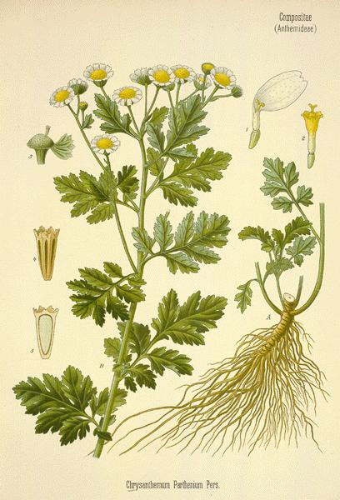
Gerard’s Herball or Generall Historie of Plantes (1597)
John Gerard

Feverfew bringeth forth many little round stalkes, divided into certaine branches. The leaves are tender, diversly torne and jagged, and nickt on the edges like the first and nethermost leaves of Coriander, but greater. The floures stand on the tops of the branches, with a small pale of white leaves, set round about a yellow ball, or button, like the wild field Daisie. The root is hard and tough: the whole plant is of a light whitish greene colour, of a strong smell, and bitter taste.

The common single Feverfew growth in hedges, gardens, and about old wals, it joyeth to grow among rubbish. There is oftentimes found when it is digged up a little cole under the strings of the root, and never without it, whereof Cardane in his booke of Subtiltes setteth down divers vaine and trifling things.

Feverfew dried and made into pouder, and two drams of it taken with hony or sweet wine, purgeth by siege melancholy and flegme; wherefore it is very good for them that are giddie in the head, or which have the turning called Vertigo, that is, a swimming and turning in the head. Also it is good for such as be melancholike, sad, pensive, and without speech.

*********
Black Hellebore
This plant hath thicke and fat leaves of a deep green colour, the upper part whereof is somewhat bluntly nicked or toothed, having sundry divisions or cuts in some leaves many, in others fewer. It beareth Rose-fashioned floures upon slender stems, growing immediately out of the ground an handful high, sometimes very white, and oftentimes mixed with a shew of purple: which being vaded, there succeed small husks full of blacke seeds.

A purgation of Hellebor is good for mad and furious men, for melancholy, dull and heavie persons, and briefly for all those that are troubled with blacke choler, and molested with melancholy.

It is agreed among the later writers, that these plants are Veratra nigra: in English, blacke Hellebores: of divers, Melampodium, because it was first found by Melampos, who was first thought to purge therewith Pretus his mad daughters, and to restore them to health. Dioscorides writeth, that this man was a shepheard: others, a Soothsayer. In high Dutch it is called Christs herbe, and that because it foureth about the birth of our Lord Jesus Christ.

The Pamphlet Wars in Renaissance England

“The rousing popular controversies in Renaissance England about the nature of woman differed from the previous writing on the topic in several ways. First, the rise of printing made possible an increase in the number of attacks and defenses and a wider dissemination of these to the middle-class populace of London, who were apparently increasingly eager for such reading matter…the “pamphlet wars” of formal attacks and defenses…can be found in all levels of literature at the time” (11).

“Roger Thompson places first in his list of popular stereotypes in Stuart England ‘that of the woman who was all tongue; the straight blabbermouth, or the gossip and scandalmonger, or the shrew or scold’…while earlier historians often assumed that women did experience enlarged freedoms, more recent historians have emphasized developments after 1500 that curtailed women’s independence. Pearl Hogrefe believes that, because of sweeping economic changes quite beyond any individual’s control, fewer women worked in large or small businesses after 1500” (51).

“If male and female sexual drives were accepted in the Renaissance, then what is the psychological origin of the seductress, and why did women evolve a parallel stereotype of the seducer? A partial answer probably lies in the fact of rather late marriage combined with strict prohibitions against premarital intercourse. The myth that Renaissance people married in their teens, fostered by Shakespeare’s Romeo and Juliet and a few well-known aristocratic marriages that took place between teenagers, has been decisively shattered by recent historians who have culled extensive statistics from records of applications for marriage licenses….the average age of the bride was 24; that of the groom was 28” (55).

“Many of the pamphlets warn men and women to exercise care and caution in selecting a mate, since their choice will be binding until death. In the English Renaissance divorce as we understand it – as the legal right to remarry – did not exist. A marriage could be dissolved only through annulment, and the English ecclesiastical laws made annulment, as well as legal separation, very difficult for either party” (74).

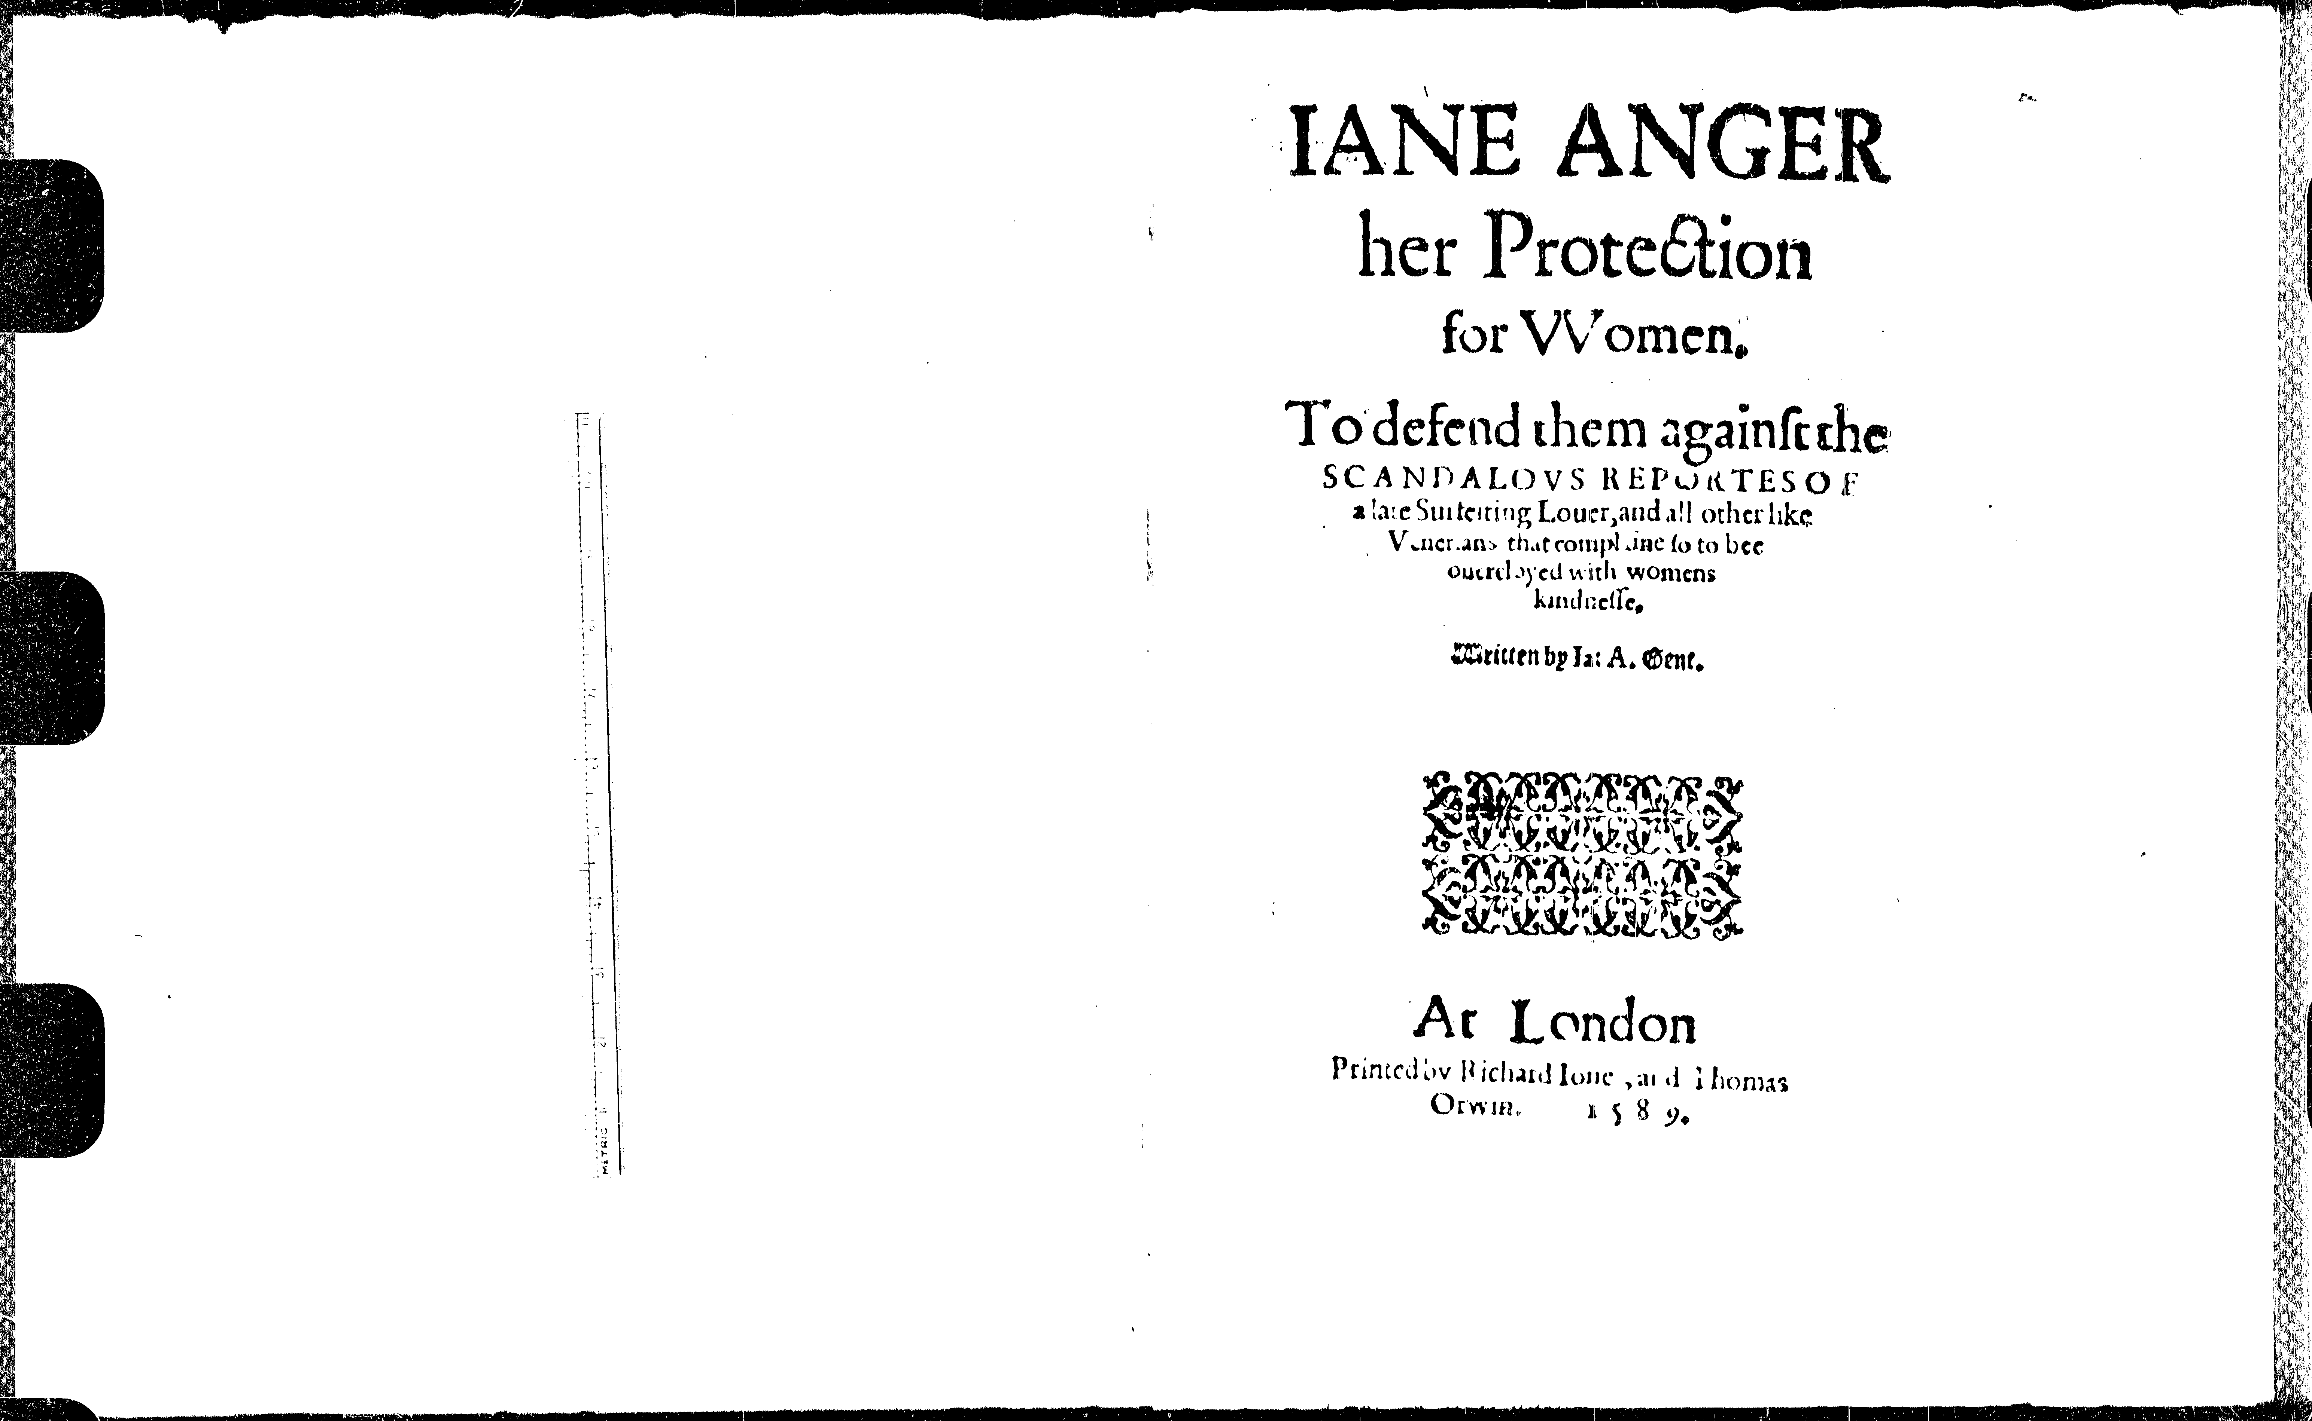

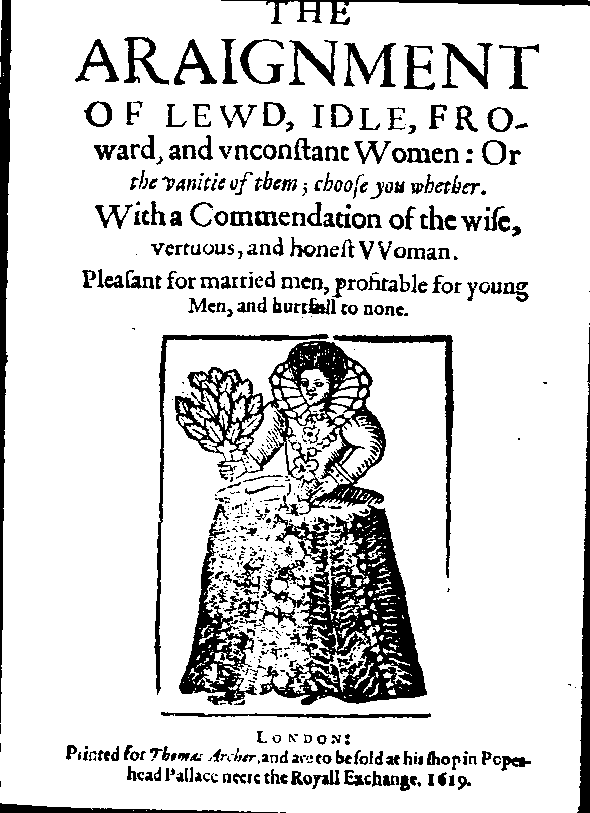

Henderson, Katherine usher and Barbara F.
McManus. Half Humankind: Contexts
and Texts of the Controversy about
Women in England 1540-1640.
Chicago: University of Illinois Press,
1985. Print.

Jane Anger, her Protection for Women To defend them against the Scandalous Reports of a late Surfeiting Lover and all other like Venerians that complain so to be overcloyed with women’s kindness, Written by Jane Anger, Gentlewoman 1589
To all Women in general, and gentle Reader whatsoever,
Fie on the falsehood of men, whose minds go often amadding, and whose tongues cannot so soon be wagging but straight they fall arailing. Was there ever any so abused, so slandered, so railed upon, or so wickedly handled undeservedly as are we women? Will the Gods permit it, the Goddesses stay their punishing judgments, and we ourselves not pursue their undoings for such devilish practices? Oh Paul’s steeple and Charing Cross! A halter hold all such persons! Let the streams of channels in London streets run so swiftly as they may be able alone to carry them from that sanctuary! …
The greatest faults that doth remain in us women is that we are too credulous, for could we flatter as they can dissemble, and use our wits well as they can their tongues ill, then never would any of them complain of surfeiting…
There is a continual deadly hatred between the wild board and tame hounds; I would there were the strength should predominate where now flattery and dissimulation hath the upper hand. The lion rageth when he is hungry, but man raileth when he is glutted. The Tiger is robbed of her young ones when she is ranging abroad, but men rob women of their honor undeservedly under their noses…
I have set down unto you the suble dealings of untrue meaning men, not that you should contemn all men, but to the end that you may take heed of the false hearts of all and still reprove the flattery which remains in all.
The Arraignment of Lewd, idle, forward, and unconstant women or the vanity of them, choose you whether, With a Commendation of wise, virtuous, and honest Women, Pleasant for married Men, profitable for young Men, and hurtful to none. Joseph Swetnam 1615
Bearbaiting or the Vanity of Women.
Woe be unto that unfortunate man that matcheth himself with a widow, for a widow will be the cause of a thousand woes. Yet there are many that do wish themselves no worse matched than to a rich widow. But thou dost not know what griefs thou joinest with thy gains, for if she be rich, she will look to govern, and if she be poor, then art thou plagued both with beggary and bondage...
It is seldom or never seen that a man marrieth with a widow for her beauty nor for her personage, but only for her wealth and riches. And if she be rich and beautiful withal, then thou matchest thyself to a she-devil, for she will go like a Peacock and thou, like a Woodcock…
Thou mayest think that I have spoken enough concerning Widows, but the further I run after them, the further I am from them. For they are the sum of the seven deadly sins, the Fiends of Satan, and the gates of Hell…
Nor I would not have women murmur against me for that I have not written more bitterly against men, for it is a very hard winter when one Wolf eateth another; and it is also an ill bird that defileth her own nest; and a most unkind part it were for one man to speak ill of another.
Henderson, Katherine usher and Barbara F.
McManus. Half Humankind: Contexts
and Texts of the Controversy about
Women in England 1540-1640.
Chicago: University of Illinois Press,
1985. Print. 173-184, 214.

William Whately
Marriage Sermon on “Women’s Roles” (1619)

Now proceede we to the womens duty, and giuing the men leaue to chew the cud awhile, request the women to listen with more diligence than before. The whole duty of the wife is referred to two heads. The first is, to acknowledge her inferiority: the next, to carry her selfe as inferiour. First then the wiues iudgement must be conuinced, that she is not her husbands equall, yea that her husband is her better by farre; else there can bee no contentment, either in her heart, or in her house. If shee stand vpon termes of equality, much more of being better than he is, the very root of good carriage is withered, and the fountaine thereof dryed vp. Out of place, out of peace. And woe to these miserable aspiring shoulders, that content not themselues to take their roome, next below the head. If euer thou purpose to be a good wife, and to liue comfortably, set downe this with thy selfe. Mine husband is my superiour, my better; he hath authority and rule ouer mee: Nature hath giuen it him, hauing framed our bodies to tendernes, mens to more hardnesse. God hath giuen it him, saying to our first mother Euah, Thy desire shalbe subiect to him, and hee shall rule ouer thee. His will is the tye and tedder euen of my desires and wishes. I will not striue against GOD and nature. Though my sinne hath made my place tedious, yet I will confesse the truth, Mine husband is my superiour, my better. If the wife doe not learne this lesson perfectly, if she haue it not without booke, euen at her fingers ends, as we speake, if her very heart condescend not to it, there will bee wrangling, repining, striuing, viyng to be equall with him, or aboue him; and thus their life wilbe but a battell, and a trying of masteries. A wofull liuing.

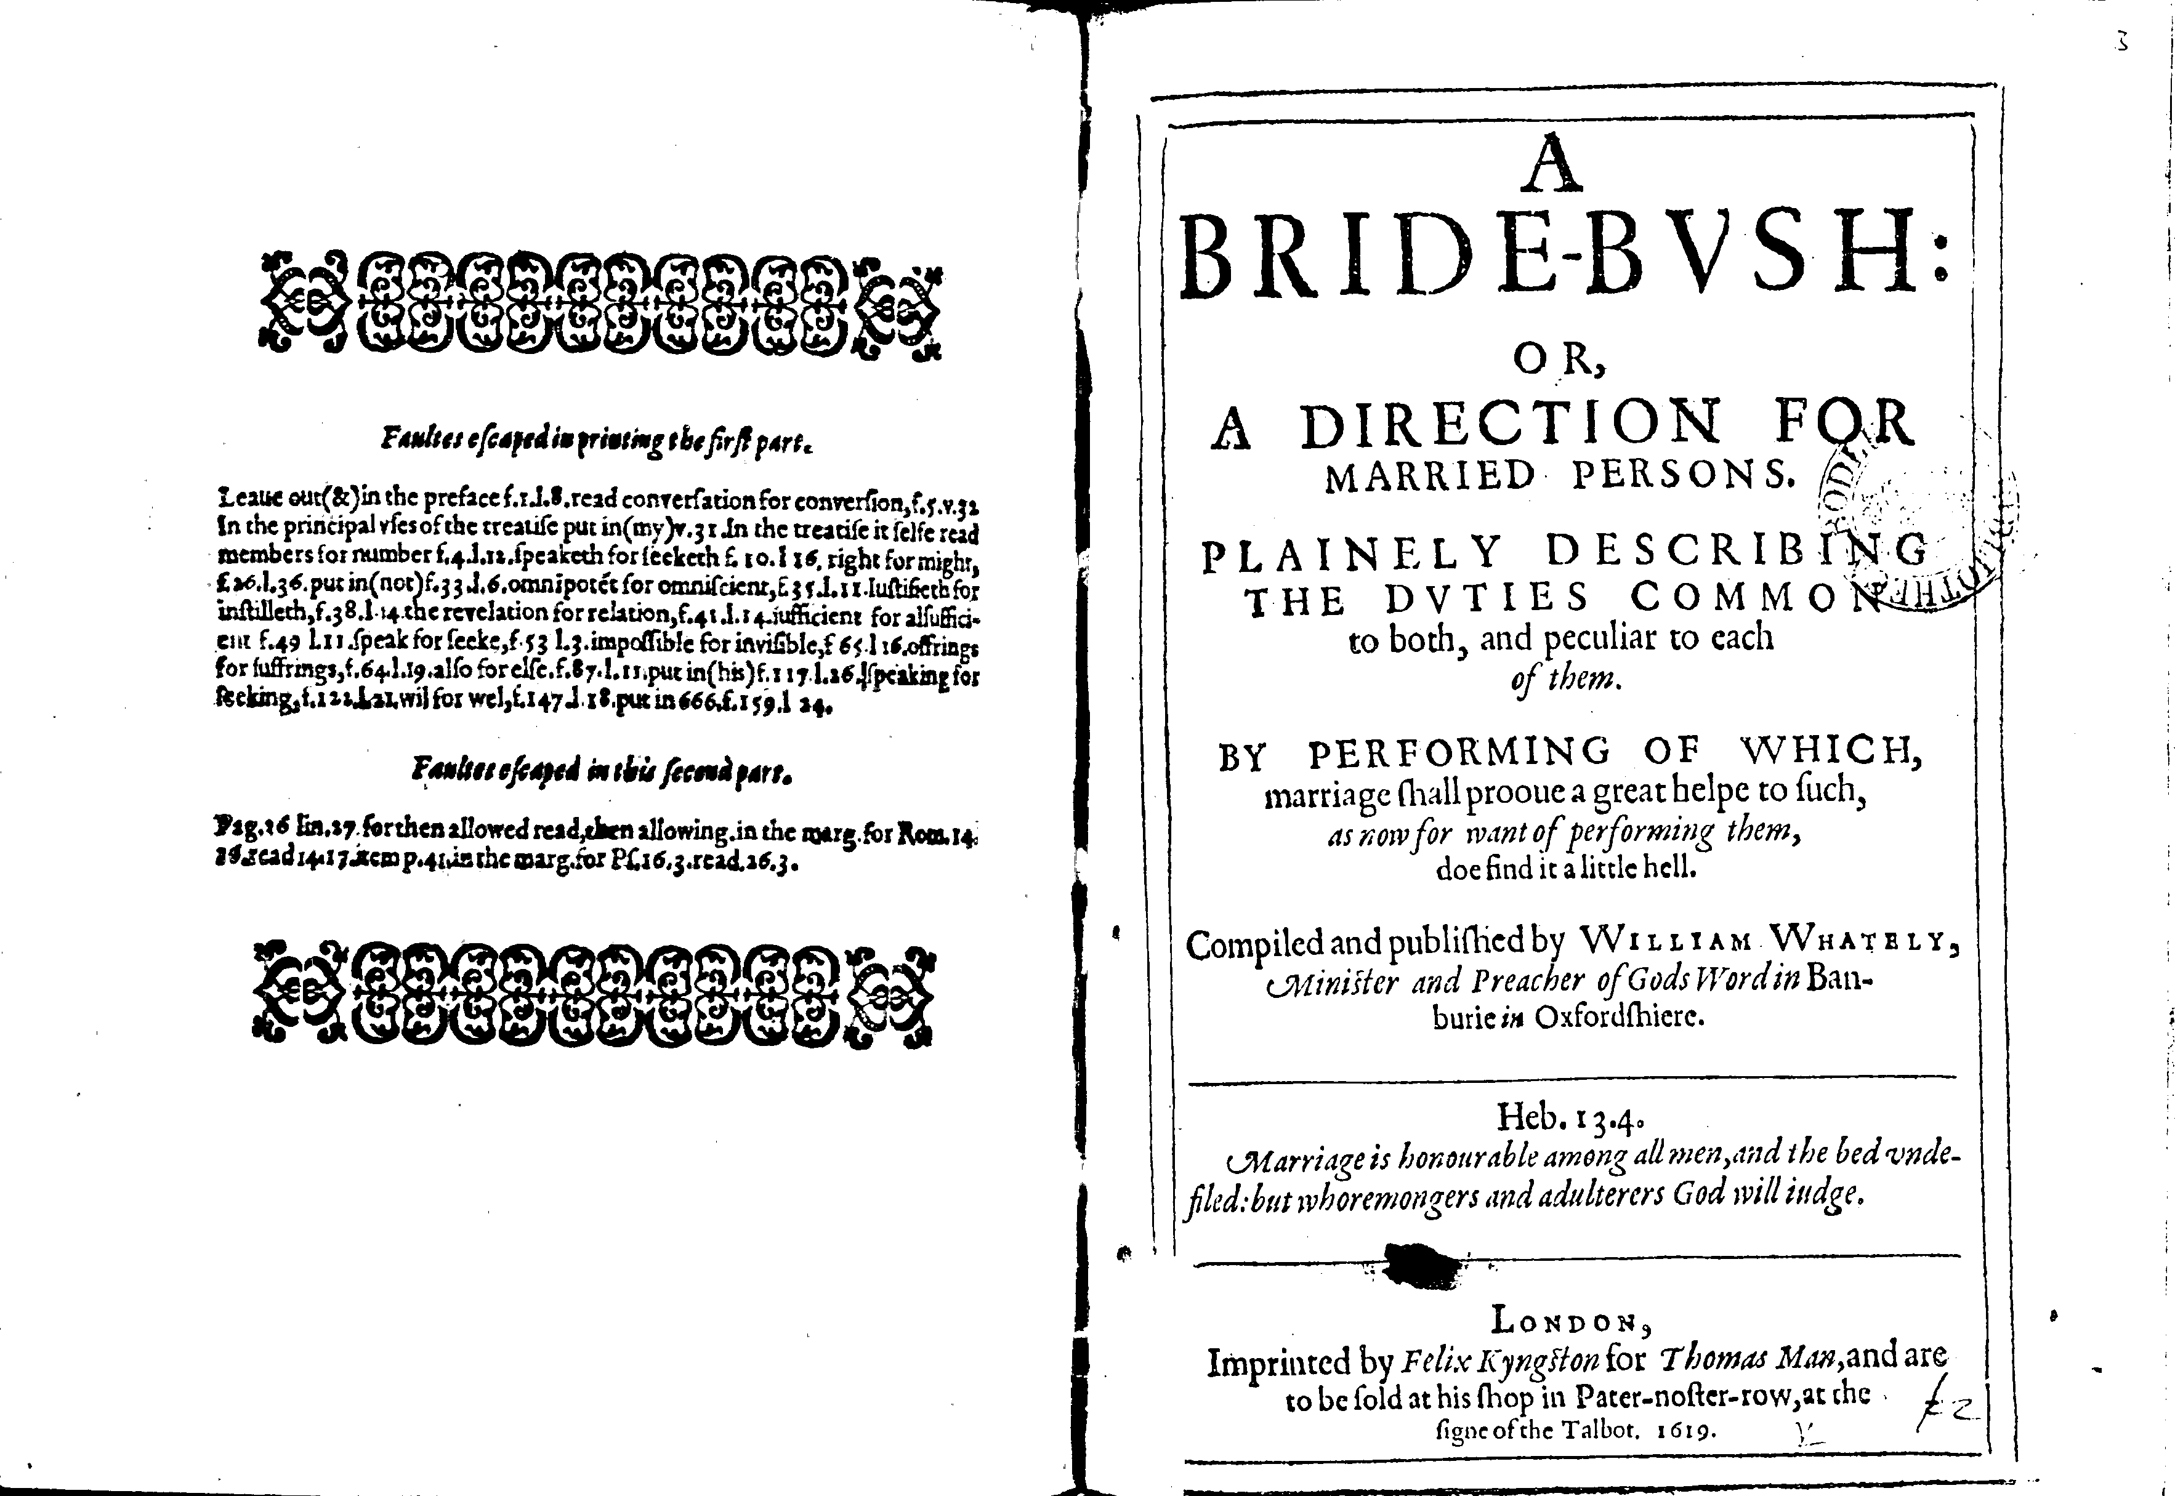
A bride-bush: or, A direction for married persons Plainely describing the duties common to both, and peculiar to each of them. By performing of which, marriage shall prooue a great helpe to such, as now for want of performing them, doe find it a little hell. Compiled and published by William Whately, minister and preacher of Gods Word in Banburie in Oxfordshiere. , London : Imprinted by Felix Kyngston for Thomas Man, and are to be sold at his shop in Pater-noster-row, at the signe of the Talbot, 1619.
Date: 1619
Bib name / number: STC (2nd ed.) / 25297
Physical description: [12], 220 p.
Copy from: Bodleian Library

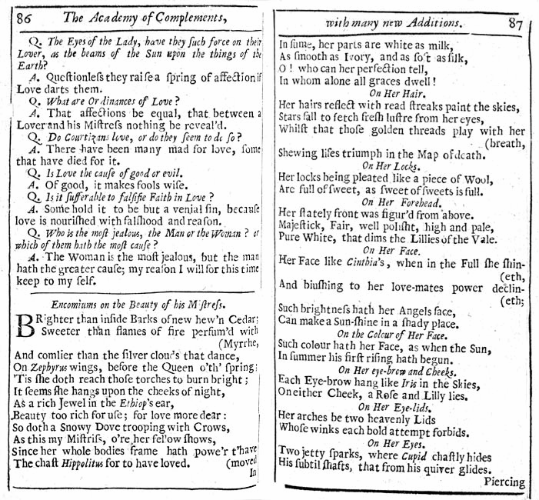
© Folger Shakespeare Library 2007

